A-ADAM, a new EU-funded project developing test systems for Alzheimer’s disease

Age-related neurodegenerative disorders represent a considerable medical and economic challenge for the health care sector. However, drug development for neurodegenerative disorders is severely hampered by a lack of predictive test systems in the preclinical phase. To address this need, the EUREKA-Eurostars initiative of the European Union approved a project grant to E-PHY-SCIENCE in Valbonne, France, CeGaT GmbH in Tübingen, Germany and the NMI at the University of Tübingen. The project aims at the development of novel drug test systems for Alzheimer’s disease. A new animal model, an in vitro test system and a new diagnostic test will be generated by combining an established genetic animal model for Alzheimer’s disease with another animal model for age-dependent mitochondrial impairment. The partners expect a considerable improvement over current drug test systems for age-dependent neurodegeneration which will speed up the validation of novel treatments.

E-PHY-SCIENCE
E-PHY-SCIENCE is a service company specialized in In-vivo and In-vitro electrophysiological assays. If you are currently developing a program in CNS disorder, we can help you increase your chances of success. By gathering on the same platform In-Vivo and In-Vitro electrophysiological assays, E-PHY-SCIENCE team is able to offer a complete range of studies. These assays can reveal specific abnormalities in many genetic models of human brain disease, as well as the effect of new molecules on normal brain functions. These types of experiment provide insights for new therapies as well as understandings of brain diseases mechanisms. We cover all your needs in electrophysiological analysis, from moving animals to single channel analysis. Backed by a Scientific Advisory Board, presided by Pr Lazdunski, and comprised of thought leading experts from industry and academia, E-PHY-SCIENCE is integrated in the renowned IPMC (CNRS) lab in Sophia Antipolis and was funded by Dr Mélissa Farinelli in 2013.
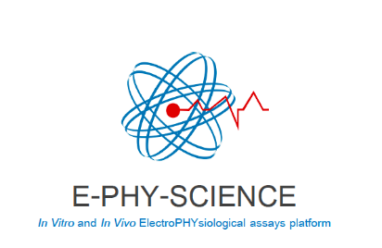

CeGaT GmbH
CeGaT is a leading global provider of genetic diagnostics and mutation-related disease analyses. The company combines its next-generation sequencing (NGS) process and analysis pipelines with its medical expertise - dedicated to identifying the genetic cause of disease and supporting patient management.
Genetic mutations can trigger a wide range of diseases, from epilepsy to Parkinson’s. Through the use of NGS, it is possible to analyze all genes associated with a disease phenotype simultaneously – both fast and effectively. An interdisciplinary team of scientists and physicians evaluates the data and summarizes the findings in a comprehensive medical report. All services are performed in-house.
The use of NGS technology is of particular interest in the field of tumor diagnostics. Since each tumor may have several genetic driving forces, CeGaT can identify these alterations and help classify which mutations are causative. With the knowledge of these tumor-specific mutations, it is then possible to choose the most optimal therapeutic strategy.
CeGaT, founded in 2009 and based in Tübingen, Germany, is accredited according to CAP, CLIA and DIN EN ISO 15189:2014. The company provides human genetics services worldwide.

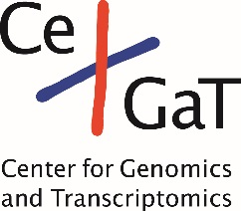

Natural and Medical Sciences Institute at the University of Tübingen
The NMI is a member of the Innovation Alliance Baden-Württemberg. It is involved in application-oriented research at the interface between the life sciences and material science. An interdisciplinary team of scientists is developing new technologies for companies and public research sponsors in the areas of pharma and biotechnology, biomedical technology, and surface and interface technology. www.nmi.de

EUREKA-Eurostars grant E! 10762 A-ADAM
