

PRESS RELEASE
November 26, 2024

Intelligent swarm
Working in a team is also relevant for drones

Uncrewed Aerial Vehicles (UAVs), commonly known as drones, are omnipresent and have grown in popularity due to their wide potential use in many civilian sectors. Equipped with sophisticated sensors and communication devices, drones can potentially form a multi-UAV system, also called swarm. Scientists from the Helmholtz Institute Freiberg for Resource Technology (HIF) and the Center for Advanced Systems Understanding (CASUS), both HZDR institutions, conducted experimental tests to set up a conceptual framework for an autonomous swarm with the specific task to efficiently scan unevenly structured environments. The tests have shown that the developed swarming concept is more resilient compared to others.
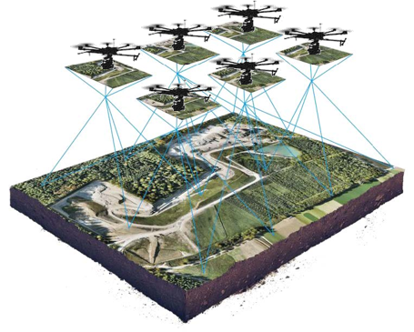
Caption: Autonomous swarms of uncrewed aerial vehicles are of great interest to both industry and the scientific community as they offer a wide range of possibilities. UAVs play an important role in civil applications such as surveying, disaster relief, forestry fire control, agriculture, transportation or geological mapping. In particular, they enable missions to be carried out in dangerous environments or environments that are difficult for humans to access.
Copyright: © HZDR/HIF

The growing interest in drones and the desire for new applications, but also the different UAV sizes, which have an impact on flight time and sensor payload, have led to the emergence of drone swarms or multi-UAV systems. An intelligent UAV swarm is a fleet of autonomous drones that cooperate according to a specific set of rules in order to carry out a complex mission efficiently without human intervention. By having multiple drones working together in hierarchical groups, the limitations of individual UAVs can be overcome so that many distributed tasks can be completed at once. The proposed conceptual framework is based on the leader-followers paradigm, where the leader drone distributes the tasks to the followers.
“Our research aims at improving economic prosperity, social development and environmental protection, for example by mitigating natural hazards, mapping the Earth surface to find new resources or monitoring the environment,” says Dr. Wilfried Yves Hamilton Adoni, scientist at HIF and CASUS, about the background of multi-UAV systems research.
“We modeled various obstacles that may occur during a swarm mission in an unevenly structured environment, i.e., an environment where information-rich, complex areas alternate with information-poor areas. Compared to the current UAV swarm configurations available, our proposed system is more resilient as it can quickly recover from system failures. We have conducted the tests considering the current state of the art in both virtual and real UAV swarms. They show that our system is reliable, trustworthy and performs consistently well. For example, our approach confirms good performance in terms of energy consumption for our scenario of large, unevenly structured areas,” continues Adoni.
Specifically, in an article published in October in the journal Drones (DOI: 10.3390/drones8100575), Adoni presented the key points that scientists should consider when designing an autonomous multi-UAV system for their research mission. He discusses aspects such as chains of command and consensus building between the UAVs, communication between the leader and the followers, and the distribution of computations between the UAVs using a specific example setup. “We are currently working on an open-source software framework for a robot operating system that is particularly suitable for such swarm missions,” explains Adoni. “The added value of such a framework is that it contains a set of powerful functions that are relevant for carrying out autonomous missions in challenging environments.”
Challenges for autonomous swarm missions
The capability of UAVs to reach inaccessible regions is an important benefit for exploratory missions. Since a swarm can be easily adapted in size to cover a large area in a short time, they are suitable for reconnaissance and surveillance missions. The recordings of each UAV can be displayed as 3D visualization in real-time (see figure). This allows the operator to achieve a realistic mapping of the environment. But there are also challenges. The most common difficulties to handle are collision avoidance and obstacle detection. Also, energy consumption and battery life remain major problems. In addition, the legal requirements for the use of UAVs differ from country to country.
UAV swarms are designed as fully distributed systems in which each drone analyzes its own environment and collaborates with others to carry out individual actions that collectively contribute to the achievement of an overall swarm goal. The operating principle of swarms is based on a family of algorithms that enable each swarm-unit to communicate and delegate mission duties, to plan trajectories, and to coordinate flying to efficiently achieve the swarm’s overall objectives. These algorithms generally operate in a highly hierarchical architecture, giving the swarm some autonomy at different levels. As a result, the human operator’s responsibility may be limited to basic oversight and higher-level engagement without direct action.

Publication:
﻿W. Y. H. Adoni, J. S. Fareedh, S. Lorenz, R. Gloaguen, Y. Madriz, A. Singh and T. D. Kühne: Intelligent Swarm: Concept, Design and Validation of Self-Organized UAVs based on Leader-Followers Paradigm for Autonomous Mission Planning, Drones, 2024 (DOI: https://doi.org/10.3390/drones8100575)
_______________________________________________________________________________
Further Information:
Dr. Wilfried Yves Hamilton Adoni | Department Exploration

Helmholtz Institute Freiberg for Resource Technology at HZDR

and

Center for Advanced Systems Understanding (CASUS) at HZDR
Phone: +49 351 260 4754 | Email: w.adoni@hzdr.de

Press Contact:

Anne-Kristin Jentzsch | Press Officer

Helmholtz Institute Freiberg for Resource Technology at HZDR

Phone: +49 351 260 4429 | Email: a.jentzsch@hzdr.de

Dr. Martin Laqua | Officer Communications, Press and Public Relations

Center for Advanced Systems Understanding (CASUS) at HZDR

Cell phone: +49 1512 807 6932 | Email: m.laqua@hzdr.de

Additional/alternative image and caption

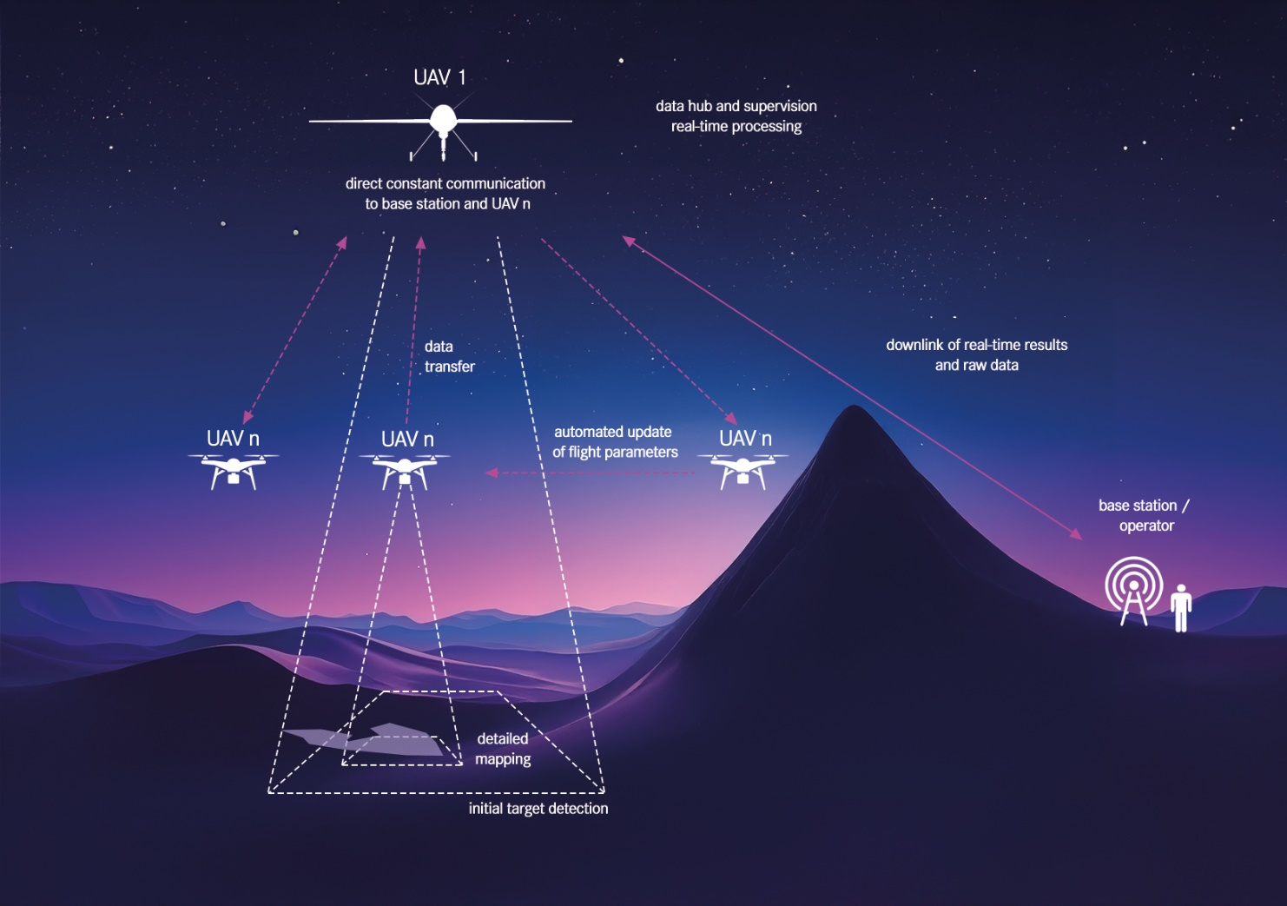

The concept presented for an autonomously operating swarm of UAVs is based on a lead drone (UAV 1), which maintains constant contact with the base station, and several follow-on drones (UAV n), some of which differ in terms of design. The collected data is processed in the swarm - as is the prioritization and distribution of tasks. The aim is that the swarm fulfills its mission without human intervention.

Copyright: © HZDR/Casus

