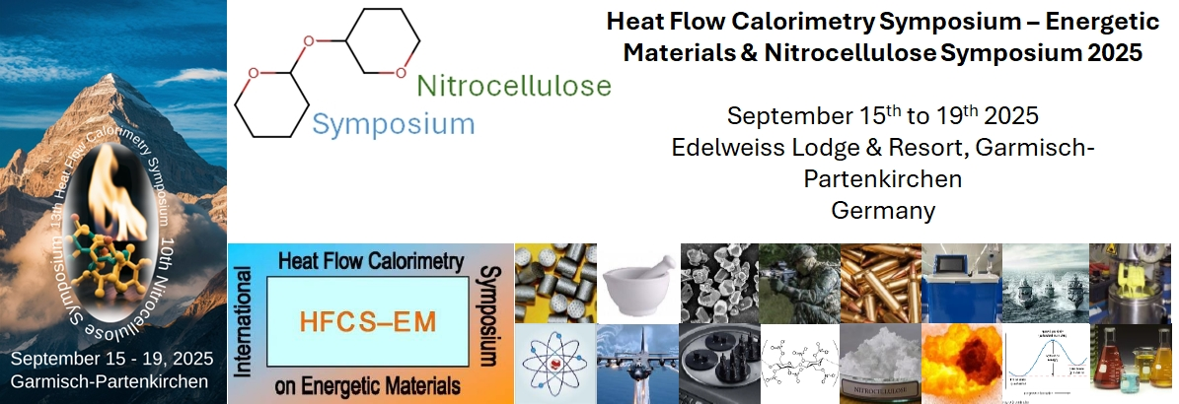

Registration Form
Participant Name:
Affiliation:
Email address:
Permission to be mentioned on the list of participants: ☐ Yes
☐ No
Contribution to scientific program: ☐ Presentation
☐ Poster
☐ Attendance only
Plan to stay at the conference venue? Lodging Rate is $180/night: ☐ Yes
☐ No
Plan to participate with the Conference Event (Conference attendees only)? ☐ Yes
☐ No
Plan to participate with the evening social (Companions 16+ welcome)? ☐ Yes
☐ No
Do you need shuttle service from/to airport? ☐ Yes
☐ No
After receipt of this form to info@nc-hfcs2025.org, you will receive additional instructions based on your input above.

