PRESS Information

Automated Vitrification Scales Functional Tissue Models

Fraunhofer IWS Establishes Reproducible Processes for Preclinical Testing and Future Applications

(Dresden, 01/20/2026) Functional tissue models are gaining importance in drug development, toxicology, and regenerative medicine. Cryopreservation, however, remains labor-intensive, error-prone, and difficult to scale. The Fraunhofer Institute for Material and Beam Technology IWS, together with other Fraunhofer institutes, has developed an automated platform that standardizes vitrification and delivers reproducible results. The “COLDIMPACT+” project, part of the Fraunhofer preliminary research program Prepare, creates industry-oriented processes that replace manual, case-by-case work and pave the way for transfer into application and production.

Manual workflows still dominate the cryopreservation of complex tissues. Precise timing of temperature changes, media exchanges, and tissue handling demands extensive experience and leaves little room for standardization. This limits throughput and complicates comparability. The new platform addresses these constraints directly.
Automation Enables Stable and Comparable Processes
The solution applies principles of industrial automation to cryobiology. Tissue sections rest on microsystem-engineered carriers that guide each process step with precision. Media exchanges, rinsing sequences, and cooling rates proceed in a controlled manner. Integrated sensors and cameras monitor every step in real time.

“We aimed to develop a process that delivers reproducible results independent of individual experience,” says Dr. Florian Schmieder, Group Manager Micro and Biosystems Engineering at Fraunhofer IWS. “Automation enables the stabilization of critical transitions and reduces manual intervention to a minimum.”

The approach preserves not only tissue morphology but also functional properties that underpin meaningful testing. The approach preserves not only the morphological structure of tissues. It also maintains functional properties that underpin meaningful testing. This makes the platform particularly suitable for preclinical applications, where comparability and repeatability matter.
Transfer Orientation from the Outset
COLDIMPACT+ follows a clear transfer strategy. A modular architecture enables adaptation to different tissue types, cryoprotectants, and process parameters. At the same time, it supports standardized protocols that anticipate regulatory requirements. Fraunhofer IWS contributes expertise in automation, microsystems engineering, and application-oriented process development. The goal is to deliver robust solutions early on that industry partners can adopt and further develop. The project unites Fraunhofer IWS with the Fraunhofer Institute for Toxicology and Experimental Medicine ITEM and the Fraunhofer Institute for Biomedical Engineering IBMT. The partners combine cryotechnology, biomedical applications, process development, and system integration. “The strength lies in the combination,” emphasizes Dr. Schmieder. “We do not develop technology in isolation. We always focus on application and later deployment.”
Significantly Higher Throughput at Consistent Quality
A key effect lies in the sharp increase in sample throughput. While manual methods typically handle ten to twenty samples per morning, automated systems can processes around one hundred to two hundred samples in the same time frame. Hands-on effort drops substantially at the same time. “Scaling determines transfer,” Schmieder emphasizes. “Only reliable and efficient processes move into industrial or clinic-adjacent environments.” The platform closes a gap between laboratory research and application. It enables standardized test series, longitudinal comparative studies, and integration into automated testing systems.
Dialogue with Users and Developers
Project results feed into the Fraunhofer IWS workshop “5th MPS User Days.” Participants will discuss the potential, limits, and next steps of automated tissue vitrification with users from research, industry, and development. The workshop addresses everyone who uses or plans to use functional cryopreservation of cells and tissues for testing, development, and translation.

Info Box
Tissue Cryopreservation
Tissue cryopreservation enables long-term storage of biological samples at extremely low temperatures. The goal is to preserve tissue structure and function in full. Vitrification poses a particular challenge, as the sample solidifies into a glass-like state without forming ice crystals. Ice crystals would damage cellular structures and impair function.

Manual cryopreservation requires precise timing, coordinated cooling rates, and experienced personnel. Deviations quickly reduce quality. Automated approaches stabilize these sensitive process steps. They increase reproducibility, throughput, and comparability. This establishes the basis for standardized preclinical testing and can significantly simplify clinical applications.

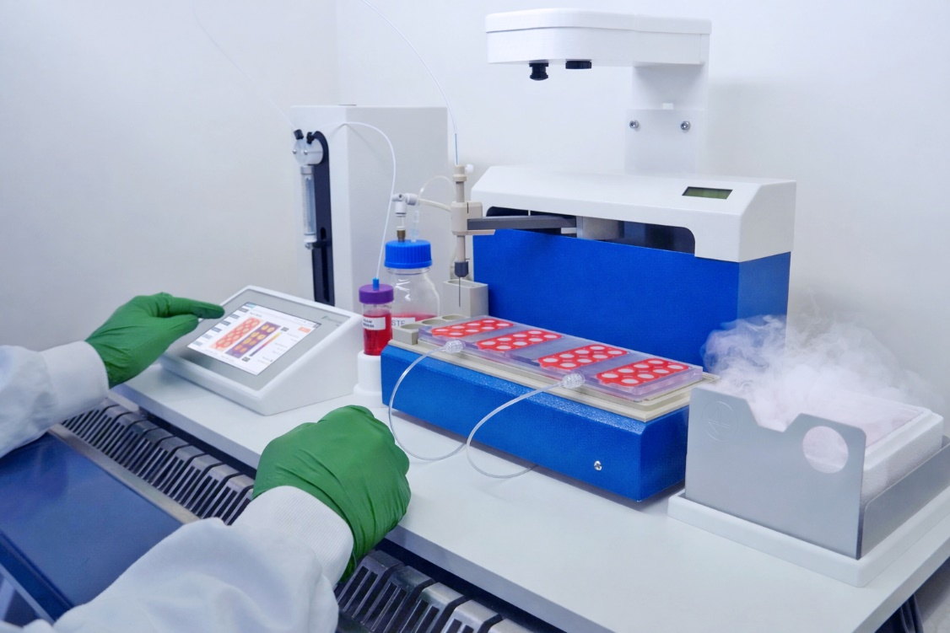
An automated plattform containing liquid handling and customized tissue carriers helps to stabilize error-prone process steps during cryopreservation. Fraunhofer IWS, together with Fraunhofer ITEM and Fraunhofer IBMT, has developed an automated platform that standardizes vitrification and delivers reproducible results.
© Fraunhofer IWS
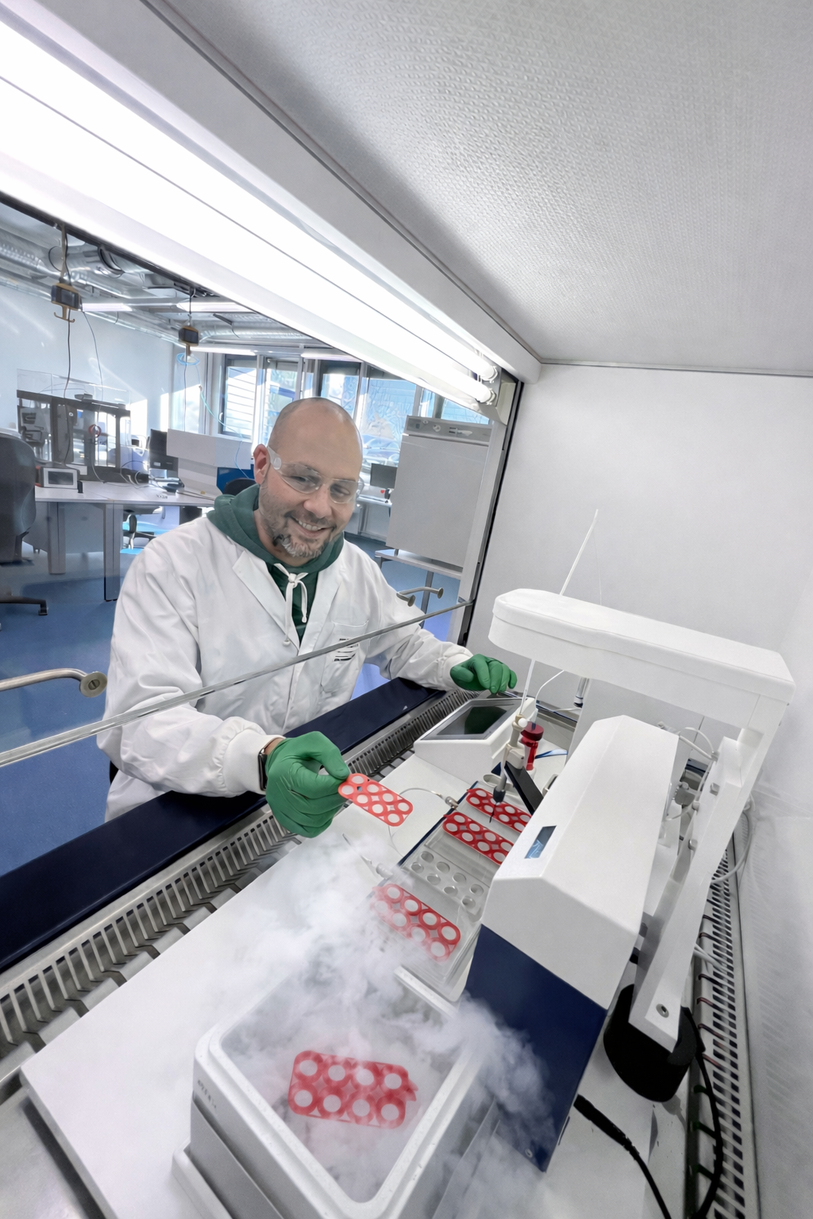
Manual workflows still dominate the cryopreservation of cells and tissues. Stepwise automation based on microsystem carriers increases standardization reliability and reduces manual effort.
© Fraunhofer IWS

Dieses Feld, sowie die Tabelle auf der letzten Seite nicht löschen!

