Data basis Bureaucracy Index
Berlin, March 5, 2026

The data source for calculating the Bureaucracy Index is the online service buzer.de, which provides consolidated versions of German federal law. buzer.de covers all federal laws and their amendment history, thereby enabling the determination of the legal status at any given reference date.
For this study, the legal status as of January 1 was evaluated for each year from 2006 to 2026.

Specifically, the analysis determined how many federal laws were in force on that reference date and what total volume in standard pages resulted from the text of all applicable laws. The use of consolidated documents made it possible to avoid double counting (for example, where previous versions expired and new versions entered into force at the same time). The quality of the data provided by www.buzer.de was verified on a random sample basis against official sources and proved to be reliable.

The evaluation proceeded as follows: First, all laws valid on the reference date were identified and counted (number of individual laws). Subsequently, the full text of each law was used to calculate its volume measured in standard pages. The sum of these normative pages represents the total volume of federal legislation on the reference date.

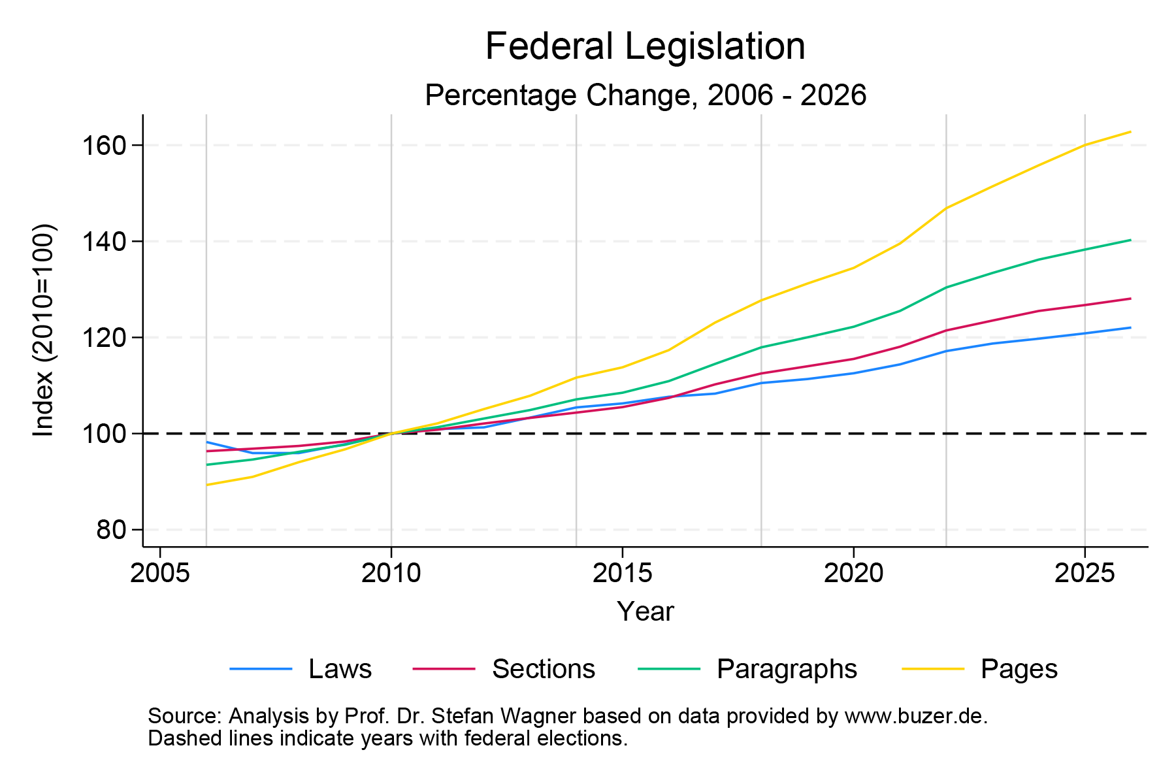

Year |  | Laws | Delta |  | Sections | Delta |  | Paragraphs | Delta |  | Normative pages | Delta
2006 |  | 1.065 | 98,2% |  | 37.654 | 96,3% |  | 93.866 | 93,5% |  | 22.068 | 89,1%
2007 |  | 1.040 | 95,9% |  | 37.858 | 96,9% |  | 94.969 | 94,6% |  | 22.514 | 90,9%
2008 |  | 1.040 | 95,9% |  | 38.084 | 97,4% |  | 96.577 | 96,2% |  | 23.301 | 94,1%
2009 |  | 1.060 | 97,8% |  | 38.444 | 98,4% |  | 98.056 | 97,7% |  | 23.953 | 96,7%
2010 |  | 1.084 | 100,0% |  | 39.088 | 100,0% |  | 100.387 | 100,0% |  | 24.765 | 100,0%
2011 |  | 1.094 | 100,9% |  | 39.404 | 100,8% |  | 101.728 | 101,3% |  | 25.306 | 102,2%
2012 |  | 1.098 | 101,3% |  | 39.904 | 102,1% |  | 103.520 | 103,1% |  | 26.047 | 105,2%
2013 |  | 1.120 | 103,3% |  | 40.362 | 103,3% |  | 105.303 | 104,9% |  | 26.732 | 107,9%
2014 |  | 1.143 | 105,4% |  | 40.792 | 104,4% |  | 107.525 | 107,1% |  | 27.661 | 111,7%
2015 |  | 1.152 | 106,3% |  | 41.240 | 105,5% |  | 108.917 | 108,5% |  | 28.197 | 113,9%
2016 |  | 1.167 | 107,7% |  | 41.991 | 107,4% |  | 111.346 | 110,9% |  | 29.084 | 117,4%
2017 |  | 1.174 | 108,3% |  | 43.087 | 110,2% |  | 114.933 | 114,5% |  | 30.473 | 123,0%
2018 |  | 1.198 | 110,5% |  | 43.977 | 112,5% |  | 118.393 | 117,9% |  | 31.620 | 127,7%
2019 |  | 1.207 | 111,3% |  | 44.561 | 114,0% |  | 120.489 | 120,0% |  | 32.482 | 131,2%
2020 |  | 1.220 | 112,5% |  | 45.159 | 115,5% |  | 122.701 | 122,2% |  | 33.261 | 134,3%
2021 |  | 1.240 | 114,4% |  | 46.150 | 118,1% |  | 126.003 | 125,5% |  | 34.494 | 139,3%
2022 |  | 1.270 | 117,2% |  | 47.475 | 121,5% |  | 130.901 | 130,4% |  | 36.344 | 146,8%
2023 |  | 1.287 | 118,7% |  | 48.278 | 123,5% |  | 133.929 | 133,4% |  | 37.461 | 151,3%
2024 |  | 1.298 | 119,7% |  | 49.057 | 125,5% |  | 136.719 | 136,2% |  | 38.534 | 155,6%
2025 |  | 1.310 | 120,8% |  | 49.540 | 126,7% |  | 138.816 | 138,3% |  | 39.571 | 159,8%
2026 |  | 1.323 | 122,0% |  | 50.067 | 128,1% |  | 140.824 | 140,3% |  | 40.270 | 162,6%

Cohort analysis

A differentiated perspective emerges when the Bureaucracy Index is calculated for key legal areas (in accordance with the official federal law reference system (Fundstellennachweise, FNA). The development of legislative activity within five-year periods (2007–2011, 2012–2016, 2017–2021, 2022–2026) can be determined as follows: the increase in standard pages is calculated as the number of standard pages at the end of the period minus the baseline value at the beginning of the period. This results in the following data:

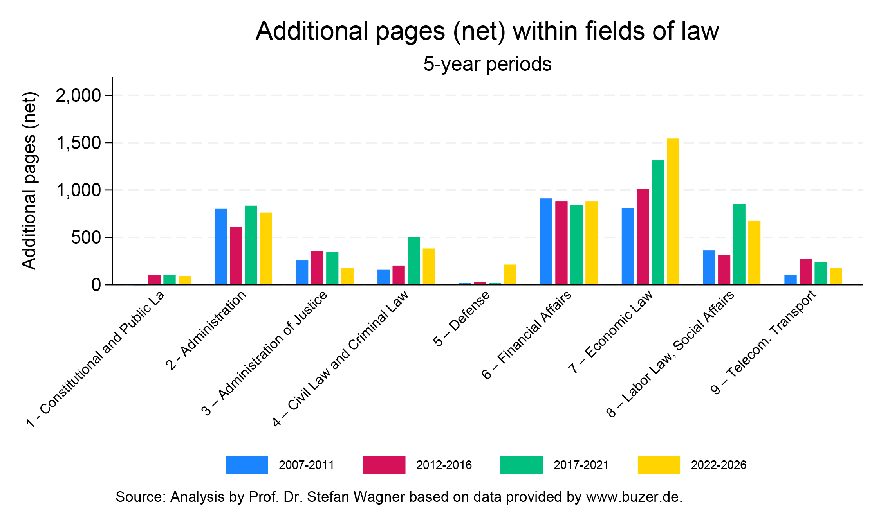

Field of law | Cohort |  | Additional pages
1 – Constitutional law | 2007-2011 |  | 6
1 – Constitutional law | 2012-2016 |  |  | 107
1 – Constitutional law | 2017-2021 |  | 106
1 – Constitutional law | 2022-2026 |  | 94
2 – Administrative law | 2007-2011 |  | 802
2 – Administrative law | 2012-2016 |  | 608
2 – Administrative law | 2017-2021 |  | 835
2 – Administrative law | 2022-2026 |  | 761
3 – Administration of justice | 2007-2011 |  | 256
3 – Administration of justice | 2012-2016 |  | 358
3 – Administration of justice | 2017-2021 |  | 347
3 – Administration of justice | 2022-2026 |  | 175
4 – Civil and criminal law | 2007-2011 |  | 158
4 – Civil and criminal law | 2012-2016 |  | 203
4 – Civil and criminal law | 2017-2021 |  | 500
4 – Civil and criminal law | 2022-2026 |  | 381
5 – Defense | 2007-2011 |  | 18
5 – Defense | 2012-2016 |  | 27
5 – Defense | 2017-2021 |  | 18
5 – Defense | 2022-2026 |  | 212
6 – Public finance | 2007-2011 |  | 911
6 – Public finance | 2012-2016 |  | 879
6 – Public finance | 2017-2021 |  | 844
6 – Public finance | 2022-2026 |  | 878
7 – Commercial law | 2007-2011 |  | 806
7 – Commercial law | 2012-2016 |  | 1.011
7 – Commercial law | 2017-2021 |  | 1.313
7 – Commercial law | 2022-2026 |  | 1.542
8 – Labor law and social affairs | 2007-2011 |  | 362
8 – Labor law and social affairs | 2012-2016 |  | 311
8 – Labor law and social affairs | 2017-2021 |  | 851
8 – Labor law and social affairs | 2022-2026 |  | 678
9 – Telecommunications and transport | 2007-2011 |  | 107
9 – Telecommunications and transport | 2012-2016 |  | 270
9 – Telecommunications and transport | 2017-2021 |  | 241
9 – Telecommunications and transport | 2022-2026 |  | 180

About ESMT Berlin
ESMT Berlin is a leading global business school with its campus in the heart of Berlin. Founded by 25 global companies, ESMT offers master, MBA, and PhD programs, as well as executive education on its campus in Berlin, in locations around the world, online, and in online blended format. Focusing on leadership, innovation, and analytics, its diverse faculty publishes outstanding research in top academic journals. Additionally, the international business school provides an interdisciplinary platform for discourse between politics, business, and academia. ESMT is a non-profit private institution of higher education with the right to grant PhDs and is accredited by AACSB, AMBA, EQUIS, and ZEvA. It is committed to diversity, equity, and inclusion across all its activities and communities. esmt.berlin

Press contact
Lennart Richter
Press Spokesperson
Phone: +49 160 552 139 3
lennart.richter@esmt.org

