PRESS Information

Sliding Systems at the Friction Minimum

“BioSlide” Builds Expertise in Sustainable Superlubricity at Fraunhofer IWS

(Dresden, 03/11/2026) Friction determines energy consumption, wear, and the service life of technical systems. Within the BioSlide research project, the Fraunhofer Institute for Material and Beam Technology IWS investigates how sliding systems can be designed to be more sustainable and energy-efficient. Funded by the Federal Ministry of Research, Technology, and Space (BMFTR) under the “BioKreativ 4” program with around 3.3 million euros, the project establishes a new interdisciplinary junior research group. The group focuses on biobased materials, lubricants, and superlubricity.

Plain bearings rank among the most widely used functional elements in mechanical and plant engineering. They operate in engines, gearboxes, pumps, and drive systems and directly influence the energy demand of entire machines. Today, sliding elements often consist of steel, bronze, or engineering plastics and operate with mineral oil-based lubricants. BioSlide pursues an alternative approach: renewable raw materials replace established materials while opening new tribological performance reserves.
Superlubricity as Core Research Topic
The project centers on superlubricity – a tribological state with a coefficient of friction below 0.01 that significantly reduces friction losses. Components generate less heat, wear decreases, and energy consumption during operation declines noticeably. Fraunhofer IWS has researched superlubricity for several years and now transfers this expertise specifically to biobased materials and lubricant systems.
“BioSlide links our superlubricity research with the pursuit of sustainable materials,” says Dr. Stefan Makowski, Group Manager Tribological Systems. “We examine whether biobased alternatives can replace conventional materials in sliding systems and which opportunities biobased lubricants offer for achieving extremely low friction.”
Coatings Enable New Material Combinations
A technological focus is on functional coatings made of tetrahedral amorphous carbon (ta-C). These coatings create smooth, wear-resistant surfaces and rank among the key enablers of superlubricity. With the Laser-Arc process developed at Fraunhofer IWS, researchers can also apply these coatings to non-conductive substrates and use them without mechanical post-processing. This capability brings biobased plastics, wood fiber composites, and other renewable materials into focus as load-bearing elements in sliding systems for the first time.
Funding Establishes New Junior Research Group
BMFTR funding supports the establishment of a new research group at Fraunhofer IWS. Over four years, scientists and technical staff jointly address how future tribological systems can conserve resources. At the end of 2025, the institute founded the Tribological Systems group under the leadership of Dr. Makowski. In addition to scientific qualifications, the project funds two doctoral positions, thereby building a long-term competence base at the institute. An advisory team from industry and international mentors supports the group.
Test Rigs Ensure Industrial Relevance
The new group consolidates specialized infrastructure for tribological investigations. Tribometers capture extremely low friction values with precision and reproducibility. A bearing test rig measures friction and wear directly in plain bearings. Complementary analyses of materials, coatings, and lubricants enable a comprehensive understanding of interfacial processes. This equipment allows realistic evaluation of new concepts and supports their development toward application.
“With BioSlide, we deliberately build expertise that connects basic research with industrial questions,” emphasizes Prof. Christoph Leyens, Institute Director of Fraunhofer IWS. “The funding allows us to address these topics in a structured way over several years.”
Alongside scientific work, industrial applicability remains a central focus. BioSlide targets mechanical and plant engineering in particular, as well as applications with high demands on energy efficiency, reliability, and environmental compatibility. The junior research group welcomes industry partnerships and offers tribological testing and development services.

Info Box
What Is Superlubricity?
Superlubricity describes a state of extremely low friction. The coefficient of friction falls below 0.01. Moving a component along its contact surface, therefore, requires less than one percent of the normal force acting on it. Surfaces slide past each other almost without resistance, energy losses drop significantly, components heat up less, and wear decreases. Superlubricity significantly increases the efficiency of technical systems and can arise across different sliding systems via various mechanisms. Of particular interest – and the focus of the project – is superlubricity achieved with robust surfaces and lubricants that can be manufactured economically.

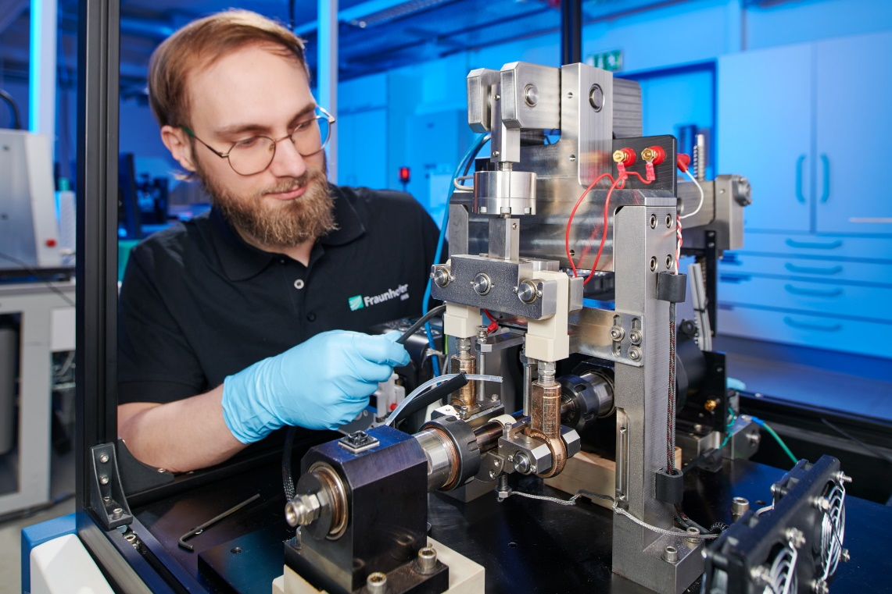
With the BioSlide research project, Fraunhofer IWS explores how to design sliding systems that operate more sustainably and energy efficiently. This plain bearing test rig enables application-oriented testing of new materials under realistic operating conditions.
© Jürgen Jeibmann/Fraunhofer IWS
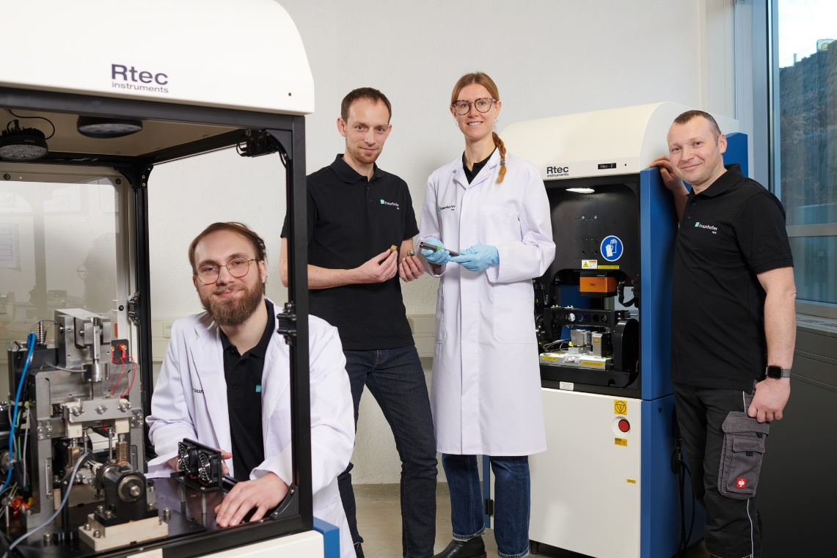
BMFTR project funding enables Fraunhofer IWS to establish an independent research team. At the end of 2025, the institute founded the Tribological Systems group under the leadership of Dr. Makowski (second from left).
© Jürgen Jeibmann/Fraunhofer IWS
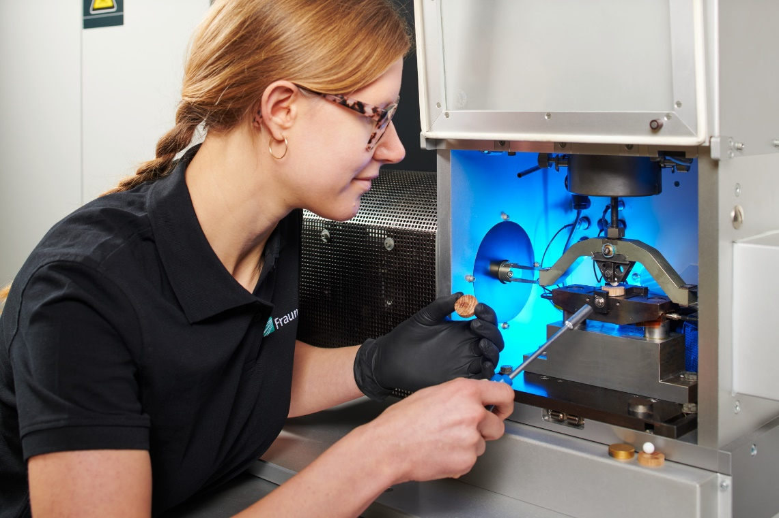
Over a four-year period, scientists and technical staff jointly investigate how tribological systems can reduce resource consumption in the future.
© Jürgen Jeibmann/Fraunhofer IWS
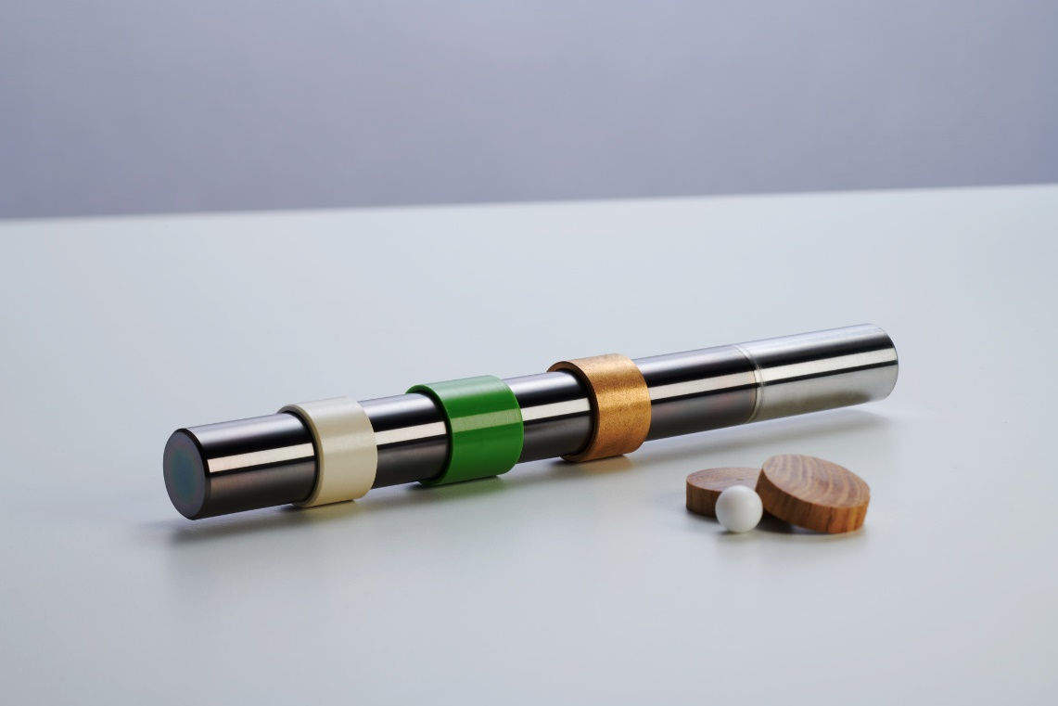
Fraunhofer IWS has investigated superlubricity for several years and now applies this expertise to biobased material and lubricant systems. A technological focus targets functional carbon coatings that create smooth, wear-resistant surfaces and enable superlubricity.
© Jürgen Jeibmann/Fraunhofer IWS

Dieses Feld, sowie die Tabelle auf der letzten Seite nicht löschen!

