PRESS Information

Real-Time Measurement Reduces Scrap in Plastic Profiles

AI-Based Measurement Technology Integrated into the Production Process for Quality Control of Fiber Composite Profiles

(Dresden, 03/18/2026) A new measurement technology reduces scrap in fiber‑reinforced plastic (FRP) profiles and enables cost‑effective, real-time process control for small and medium-sized enterprises. Researchers developed the system in the PulLoop project led by the Fraunhofer Application Center for Optical Metrology and Surface Technologies AZOM. Together with Fraunhofer IGCV, the team developed an integrated measurement system that monitors product quality in real time during production and feeds the results back into the manufacturing process.

Fiber‑reinforced plastic profiles serve as key components in lightweight construction. Manufacturers typically produce them using pultrusion, a process that offers cost advantages but often introduces quality uncertainties in practice, especially with changing profile geometries or small batch sizes. Fraunhofer AZOM contributes expertise in optical surface metrology and AI‑based image analysis. The solution developed in the project, SURFinloop, uses low‑cost scattering sensors that continuously record surface data and compares it with digital reference models known as digital twins. Modular software evaluates the data and detects geometric tolerance deviations with high precision. The system then feeds this information directly back into the production process in a closed loop.
Technology for Small and Medium-Sized Enterprises
“Existing systems for quality monitoring in pultrusion are either too expensive or too complex to implement,” explains Alexander Kabardiadi‑Virkovski, project manager at Fraunhofer AZOM. “SURFinloop addresses the needs of small and medium‑sized enterprises.” The demonstrator detects deviations of less than 100 micrometers at production speeds of up to two meters per minute. Training the software takes less than one hour. Companies can implement the measurement technology for only a few thousand euros per system — a decisive advantage in cost‑sensitive industries such as automotive manufacturing or wind energy. The system adapts to different production lines and scales to a range of component geometries.
Synergy of Sensor Technology and Process Data Management
Fraunhofer IGCV contributes expertise in intelligent process data management and structured knowledge preparation for technology transfer to small and medium‑sized enterprises. The partners aim not only to monitor production but also to stabilize and optimize it through systematic analysis and feedback. PulLoop demonstrates how digital production technologies and AI‑based methods can become accessible to smaller companies.

Info Box
Pultrusion – Efficient Production of Fiber-Reinforced Profiles
Pultrusion is a continuous manufacturing process for fiber‑reinforced plastic profiles. Continuous reinforcing fibers are impregnated with a resin matrix, pulled through a heated forming die, and cured. The process enables cost‑efficient series production of profiles with consistent quality, for example, for vehicle components, window frames, or rotor blades. Because production runs at high speed, even small deviations can create large volumes of scrap. Precise inline monitoring has therefore been difficult to implement both technically and economically. SURFinloop addresses this challenge.

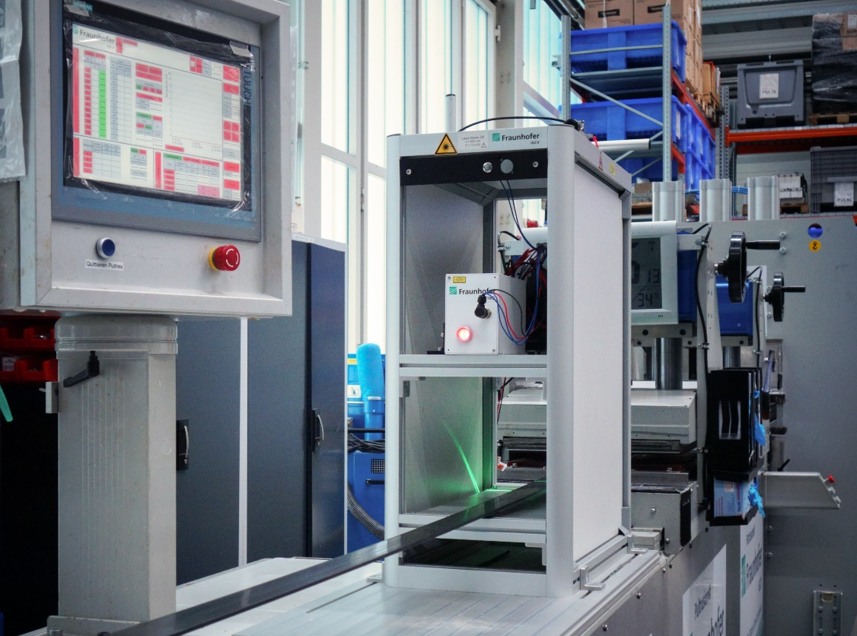
Researchers developed an integrated measurement system in the PulLoop project that monitors product quality directly during production.
© Fraunhofer IGCV
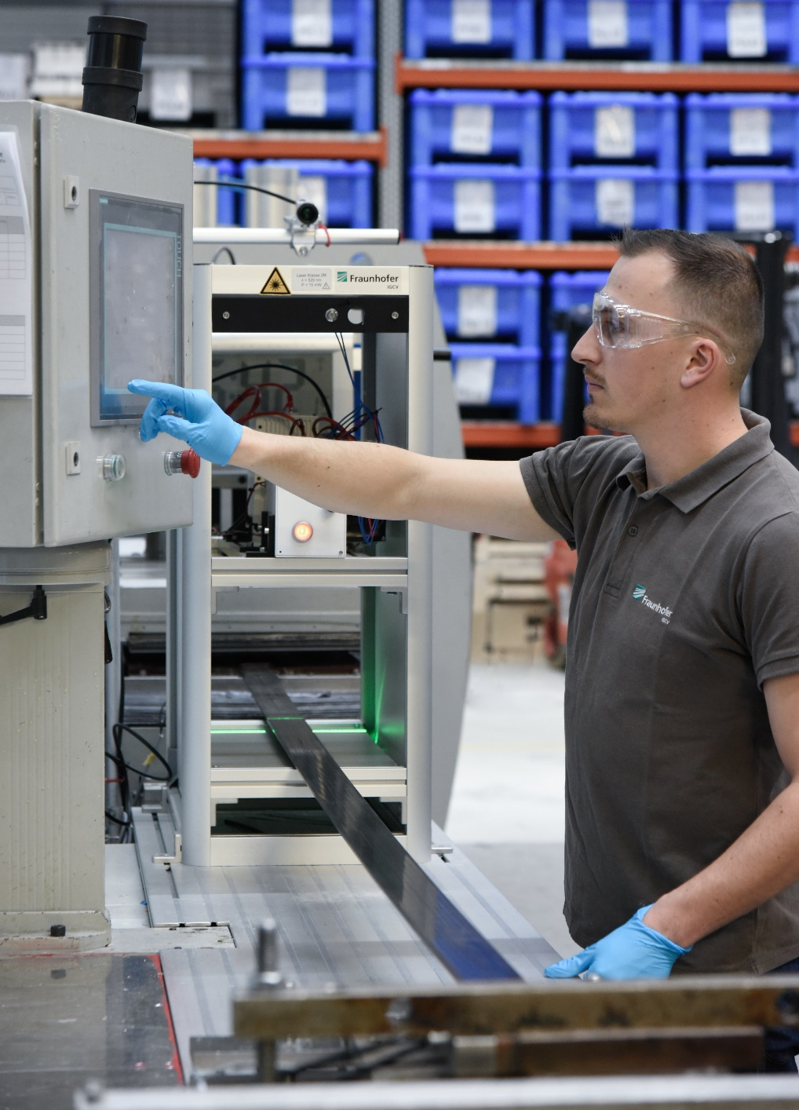
Conventional systems for quality monitoring in pultrusion are often too expensive or too complex to implement. SURFinloop targets the needs of small and medium‑sized enterprises.
© Fraunhofer IGCV
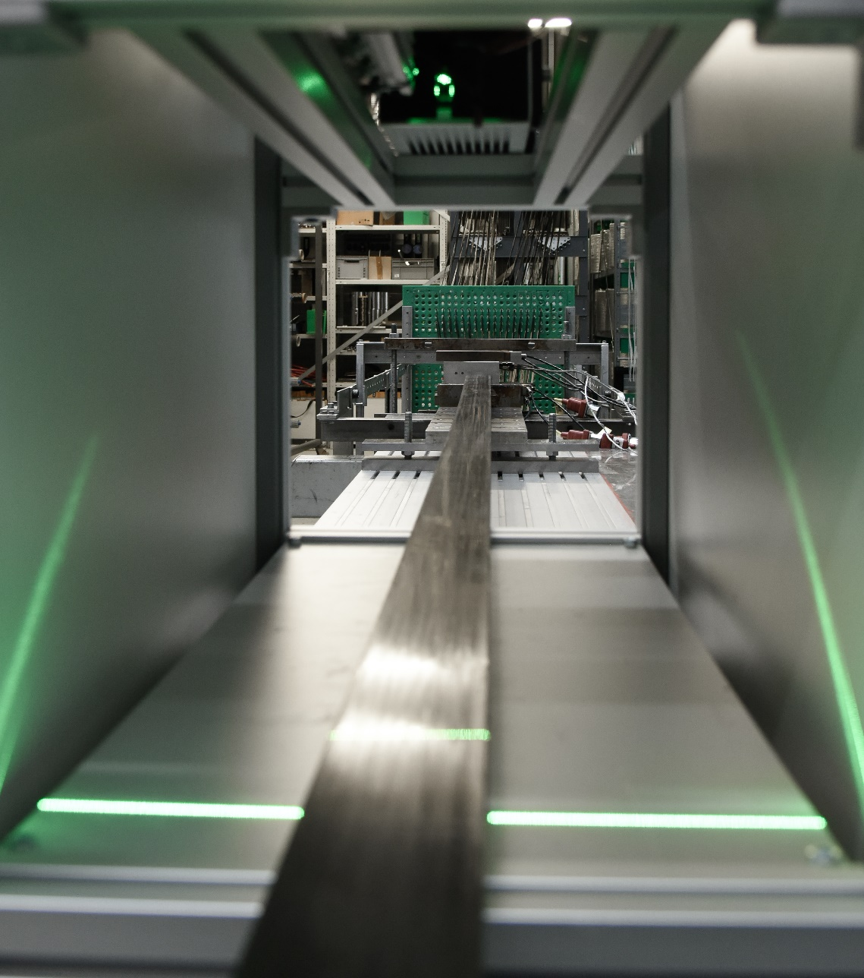
The demonstrator detects deviations of less than 100 micrometers at production speeds of up to two meters per minute.
© Fraunhofer IGCV

Dieses Feld, sowie die Tabelle auf der letzten Seite nicht löschen!

