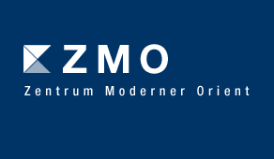
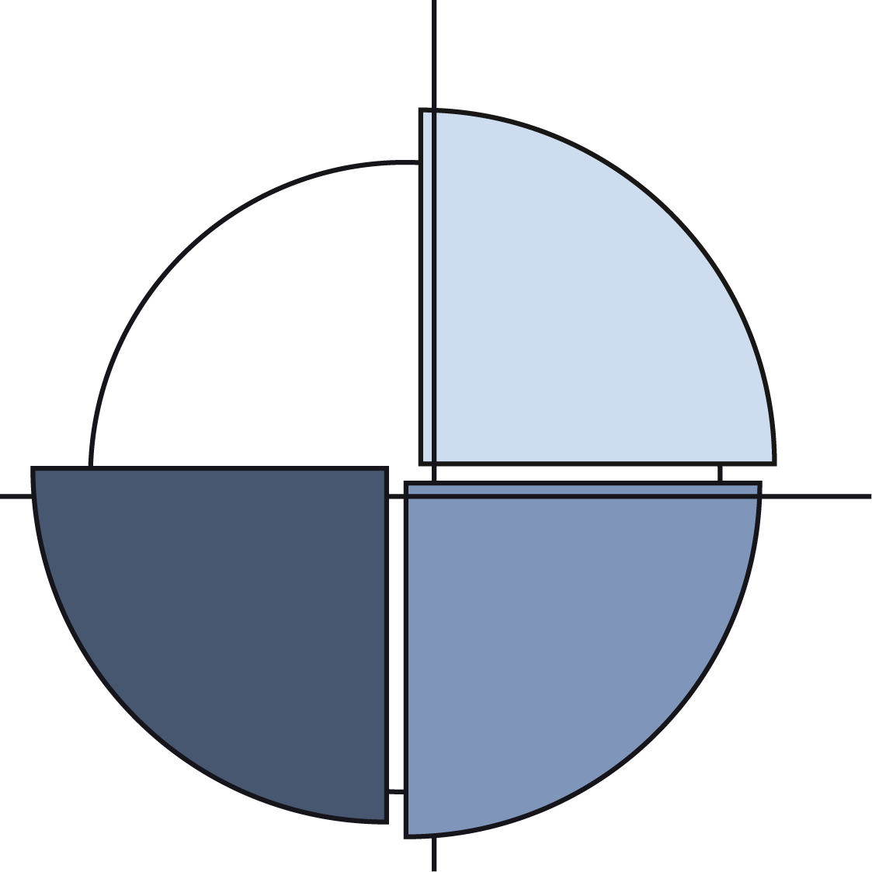Sonderforschungsbereich 640

Workshop
New Voices, New Media, New Agendas?
Pluralism and Particularism in the Middle East and North Africa

9-11 February 2011

9 February 2011
18:00-20:00 Panel I
Round Table Discussion on Media and the Process of Transition in Iraq since 2003
Zuhair al-Jezairy, Editor-in-Chief of Aswat al-Iraq
Klaas Glenewinkel, Media in Cooperation and Transition
Siruan H. Hossein, Rudaw Newspaper
Chair: Andrea Fischer-Tahir

10 February 2011
10:00-10:30 Welcome
11:00-13:00 Panel II: Media and State-organized Freedom and Repression
Daniella Kuzmanonic, University of Copenhagen
Policy Change and Institutional Continuity: Towards an Anthropology of the Radio and Television Supreme Council in Turkey
Nuaiman Keeprath Andru, Curtin University (Miri/Malaysia)
Trajectories of Media Laws: Lessons from Qatar’s Recent Past
Christian Sinclair, University of Arizona
Broadcasting False Information: Silencing of Kurdish Voices in Syria
Discussant: Eva Savelsberg, European Centre for Kurdish Studies, Berlin
Lunch

14:00-15:30 Panel III: Pluralisms from Below: Youth, Women, and the New Media
Ines Braune, University of Leipzig
Public, Private Cyberspace: Gender and Internet in the Arab World
Marcus Michaelsen and Benjamin Stachursky, Universities of Erfurt and Potsdam
The Internet and Women’s Rights Activism in Iran
Discussant: Bettina Gräf, ZMO
Coffee break

16:00-17:30 Panel IV: Pluralism or Plurality of Particularistic Voices?
Gillian Kennedy, King’s College London
The Transformation of the Egyptian Islamists: Genuine Value Pluralism or Democratic Window-dressing?
Ghada al-Akhdar, Cairo University
Political Pluralism in Cyberspace: Facebook and the Middle East Issue
Discussant: Carola Richter, University of Erfurt

18:30 Dinner at ZMO

11 February 2011
10:00-12:00 Panel V: Regional Focus Morocco
Ghomari Taibi, University of Mascara
The Maghrib: Society, Identity and Unification
Kristin Pfeifer, Max Planck Institute Halle
Constructing offline Identity online: The Case of the Moroccan Amazigh Movement
Sophie Wagenhofer, ZMO
Jewish Voices in Debates on Pluralism in Morocco
Discussant: Sonja Hegasy, ZMO
Coffee break and Snack

12:30-14:30 Panel VI: Regional Focus Iraq
Eszter Spät, Central European University Budapest
Yezidis: Images of a Shifting Identity in Iraq
Anja Wollenberg, University of Erfurt
Pluralisms and Particularism in Iraqi TV since 2003
Andrea Fischer-Tahir, ZMO
Particularism versus Pluralism in the Iraqi Press since 2003: The Example of Kurdistan-î Nwê
Discussant: Achim Rohde, Center for Near and Middle East Studies at Marburg University
Coffee Break

15:00-15:30 Final Discussion and Conclusion

