PRESS IMAGES
SHOOT & THINK
11/03/2022—27/03/202
frei_raum Q21, MuseumsQuartier Wien

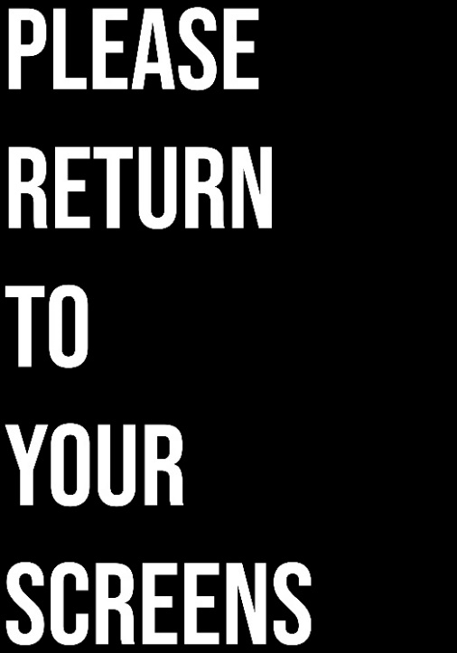1
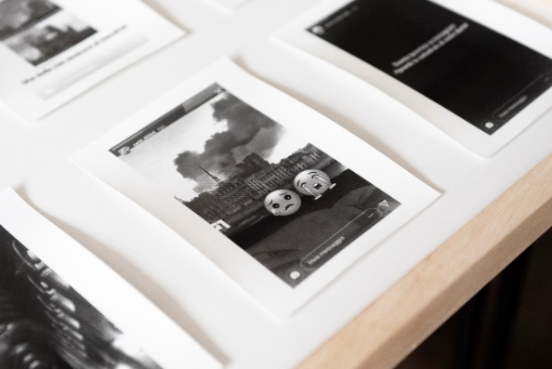 2
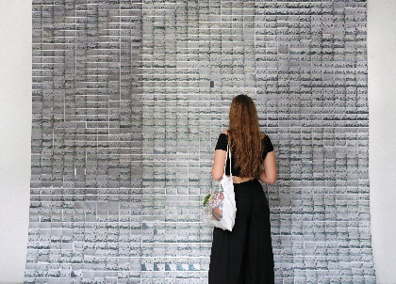 3
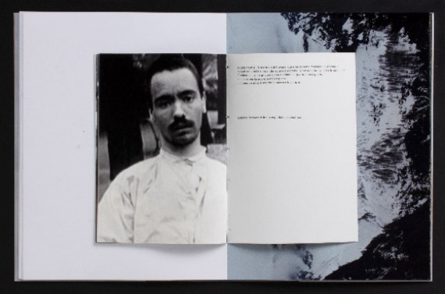 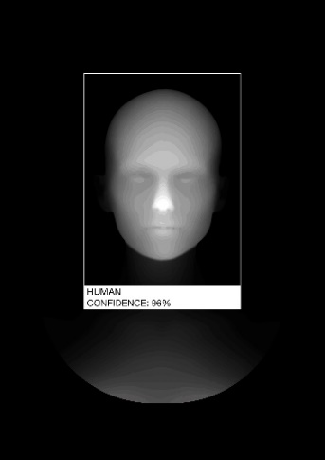 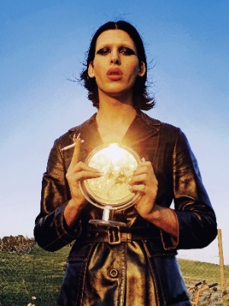 4 5 6 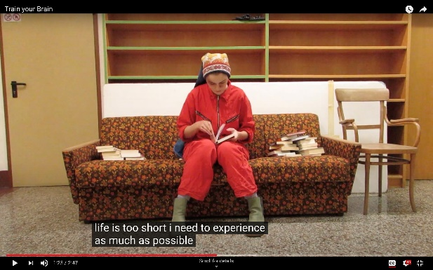 7 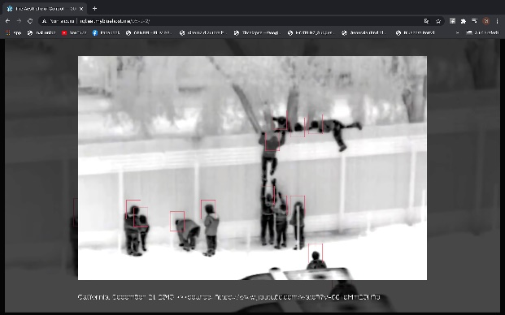 8
1 Christina Vieira-Barry, Please Return To Your Screens (poster), 2021 / ©Christina Vieira-Barry

2 Matteo Zoccolo, So Heartbreaking (detail), 2018 / ©Matteo Zoccolo

3 Elisa Faletti, Incidents and Situations from Common Life / Chapter II (detail), 2019 / ©Elisa Faletti

4 Chiara Cortellini, La guerra in testa, 2019 / ©Chiara Cortellini

5 Mark Markin, NONA (detail), 2020 / © Mark Markin

6 Luca Piscopo, Candy Oscuro: Apocalypse & Genesis, 2020 / ©Luca Piscopo

7 Elio Pfeifauf, Wendeltreppen (video still), 2021 / ©Elio Pfeifauf

8 Michelangelo Boldrin, Through the Eye: The Aesthetics of Control (website), 2020 / ©Michelangelo Boldrin

A selection of max. four images may be used free of charge at one time, three
months before beginning and until the end of the exhibition in the context of editorial
reporting only. They must not be used for commercial purposes or shared with third
parties. They may not be modified, cropped, or printed over. Please always include
the correct copyright notices and retain the captions supplied with images. Publications
must mention Freie Universität Bozen, the artist, and the exhibition.

High-resolution image files will be provided by the Free University of Bozen-Bolzano press office upon
request. Contact: vicky.rabensteiner@unibz.it.

