

**PRESS RELEASE**

**January 28, 2025**

**The raw material detectives**

**New modeling methods and geochemical analyses provide information about deep deposits**

**The growing demand for raw materials makes mining unavoidable. The exploration of deposits increasingly relies on more environmentally friendly methods. In the European DeepBEAT project, scientists at the Helmholtz Institute Freiberg for Resource Technology (HIF), an institute of the Helmholtz-Zentrum Dresden-Rossendorf (HZDR), are pursuing the approach of using geochemical analyses to detect deep-seated ore deposits in a non-invasive manner. The researchers are testing the methods in three areas in Germany, the Czech Republic and Finland. The integrative involvement of all participants is an essential part of the project in order to improve mutual understanding in exploration projects. The EU is funding the three-year project with five million euros.**

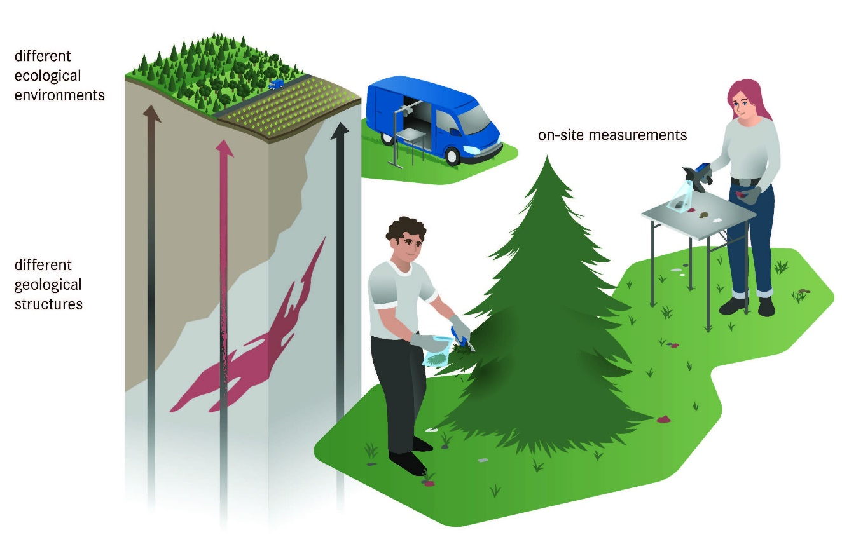

Deep Exploration of concealed, deep-seated deposits of rare earth elements, cobalt and lithium boosted by advanced exploration technologies with geochemical methods at the surface © HZDR/Blaurock

Our high-tech lifestyle is causing the raw materials consumption to rise continually. Despite intensive research into more effective processes, the demand cannot be met by recycling alone. At the same time, there is a growing awareness of our geopolitical responsibility regarding raw materials extraction. Both of these factors lead to the realization that raw materials must increasingly be extracted from European sources in a socially and environmentally responsible manner. New methods are needed to detect raw material-rich deposits in Europe - especially for deep-seated deposits, as neither geophysical nor geochemical signals from deep layers are easily distinguishable from signals close to the surface. To this end, scientists from six countries have joined forces to apply geochemical analysis methods for exploration and implement new forms of modeling in the European research project DeepBEAT (Deep exploration BoostEd by Advanced exploration Technologies).

**Search for deep-seated deposits using geochemistry**

Geochemistry is an important tool for many geoscientific questions. It provides insights into the material composition, distribution, stability, and cycle of chemical elements and their isotopes in minerals, rocks, soils, water, the Earth's atmosphere, and the biosphere. "In geological exploration, geochemical approaches are typically used to analyze core samples in order to interpret information from depth. In the case of surface samples, geochemistry is traditionally applied to soil samples to detect, for example, abnormally high metal concentrations in soils. This typically only identifies near-surface ore deposits. Geochemical methods have been tested in a few studies to detect deeper deposits, and these have shown promising results," explains Dr. Solveig Pospiech, project leader at HIF.

The detection of deep deposits is complicated by the distance between the surface and the ore body as a signal source. The challenge is to provide effective methods for improving the signal-to-noise ratio. These methods are intended to distinguish whether a measured signal originates from nearby sources – for example from outcropping rock or contamination from industrial activities - or from a deep source – i.e. a potential deposit. By tracing underground material cycles, scientists are gaining a better understanding of the geological situation. A key factor is selecting meaningful sampling points in the field and the materials to be sampled.

**Three European test areas for validation**

"We combine analysis results from handheld scanners and field measurement devices with high-resolution laboratory methods for isotope and full element geochemistry, as well as the latest 3D data processing techniques, to differentiate the sources. We then compare the findings with knowledge of the geological situation and the formation of the deposit. This enables us to make statements about the potential deposit. All methods are designed to be minimally invasive, meaning they have little or no impact on the subsurface and incorporate existing datasets," Pospiech describes the approach.

DeepBEAT will test the effectiveness of the analytical methods on three different types of deposits: In the Ore Mountains it is a tin-tungsten-lithium mineralization, in the Czech Republic a rare earth deposit will be examined and in Finland a sulphide ore deposit. This will explore which approaches support the discovery of deep-seated deposits in different geological environments and which specialized innovations are helpful for certain mineralizations.

**Involvement of all stakeholders in the exploration project**

“Mining is a polarizing issue, and this begins with exploration, even if exploration techniques have minimal impacts on the environment and society. The mere inspection of a potential exploration area by a mining company often raises concerns about the possibility of mining in one’s own backyard. Therefore, transparency, open communication, and mutual understanding are even more important. Mutual acceptance of all stakeholders is thus a key aspect of DeepBEAT,” Pospiech explains.

To achieve this, transparent communication between the explorers and all stakeholders of the test sites will be pursued from the outset, for example, by informational events where the project and the so-called "Ultra-Low-Impact" methods (methods with minimal impact on the environment and society) will be presented. The insights gained from concerns will be integrated into the exploration workflow alongside the scientific results. This aims to improve societal acceptance of mining activities.

Project Partners:

Geological Survey of Finland, Finland

Czech Geological Survey, Czech Republic

Queens University, Canada

Beak Consultants GmbH, Germany

FinnCobalt Oy, Finland

IMA engineering, Finland

LC Innoconsult International, Hungary

Université de Lorraine, France

Associated Partners:

SciAps Inc., USA

Zinnwald Lithium GmbH, Germany

**Further Information:**

Dr. Solveig Pospiech | Department Modelling and Valuation

Helmholtz Institute Freiberg for Resource Technology at HZDR

Phone: +49 351 260 2438 | Email: [s.pospiech@hzdr.de](mailto:s.pospiech@hzdr.de)

**Press Contact:**

Anne-Kristin Jentzsch | Press Officer

Helmholtz Institute Freiberg for Resource Technology at HZDR

Phone: +49 351 260 4429 | Email: [a.jentzsch@hzdr.de](mailto:a.jentzsch@hzdr.de)