Press Release

**Hanover Trade Fair 2017: Fraunhofer IOSB presents Industry 4.0**

**The Fraunhofer Institute of Optronics, System Technologies and Image Exploitation from Karlsruhe will be present at the Hanover Trade Fair 2017 from April 24 to 28 in Hanover. This year the Fraunhofer Booth is all about »Industry 4.0«. In Hall 2 Booth C16 and C22 the IOSB will be showing interactive exhibits - research on touching and testing.**

**Cyber Security Training Lab for Industry 4.0**

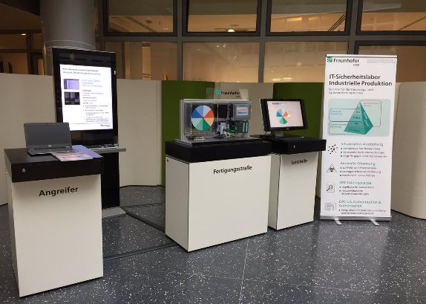The Fraunhofer Academy, which brings together industry and research by providing educational training and development on behalf of the Fraunhofer-Gesellschaft, is using the event as an opportunity to showcase its broad portfolio of further education and training options for logistics and production specialists and managers. Anyone interested in further education and training should visit the Fraunhofer Gesellschaft main booth to find out about the new program »Cyber Security Training Lab.«

The Cyber Security Training Lab © Fraunhofer IOSB

**M²-Assist** 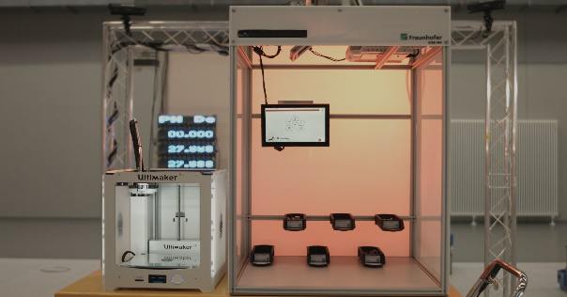

M²-Assist © Fraunhofer IOSB

The demonstration platform M²-Assist of Fraunhofer IOSB combines state-of-the-art machine vision with innovative assistance functions to support the operator in work situations of a transformable assembly environment. Intuitive human-machine interfaces in conjunction with current standards of platform independent communication enable distributed collaboration between multiple workstations and outline future forms of efficient variant-rich production.

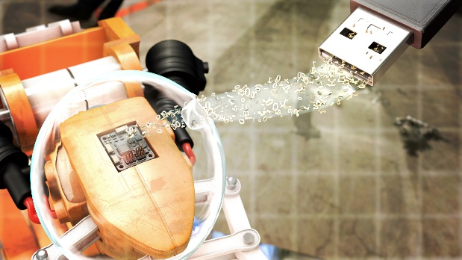**PLUGandWORK-Cube**

A central idea of Industrie 4.0 is that tangible things involved in manufacturing comprehensibly describe their unique identity and their capabilities. Fraunhofer IOSB has now launched a piece of hardware (PLUGandWORK-Cube) to upgrade existing machines for Industrie 4.0 compliant self-description and communication. It consists of an Industrial PC with an assisting system that supports the user to simply describe his machine graphically. From this description the Cube builds an AutomationML-model and generates the information model of an OPC UA-server.

The PLUGandWORK-Cube © Fraunhofer IOSB

**Smart Factory Web**

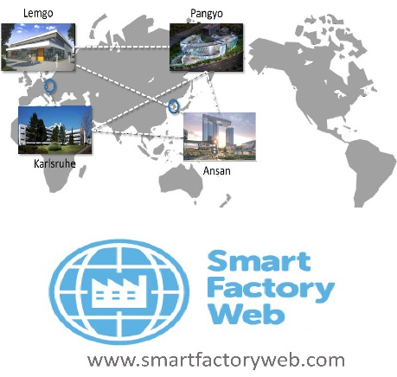Smart Factory Web is realized by the Korea Electronics Technology Institute (KETI) and Fraunhofer IOSB and is an approved Testbed of the Industrial Internet Consortiums. Flexible adaptation of production capacities and capabilities is enabled in a network of factories. The Industrie 4.0 Use Cases »order controlled production« and »adaptable factory« are implemented. The exhibit shows the dynamic integration of processing stations with Plug & Work.

Smart Factory Web © Fraunhofer IOSB

**IOSB.BoB - Algorithm-Toolbox for Autonomous Mobile Robots**

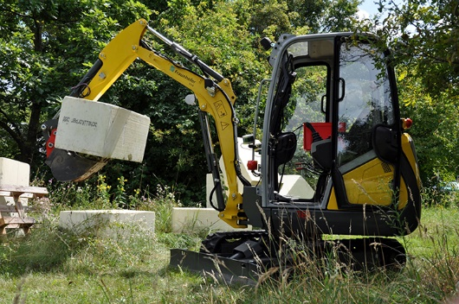Autonomous mobile robots have to cope with various tasks and environments. For this purpose, Fraunhofer IOSB has developed a toolbox consisting of software modules that can be combined in a flexible manner depending on the considered application. A digital map table visualizes the perceived environment and allows to coordinate the autonomous robotic systems. Possible applications include the exploration and mapping of contaminated areas by autonomous mobile robots and the recovery of hazardous material by automated excavator machines.

The autonomous mobile Robot IOSB.BoB © Fraunhofer IOSB

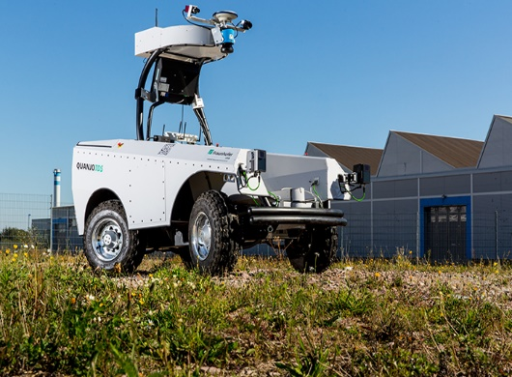  
**Seneka**

In case of emergency, the emergency forces quickly need to get an overview of the situation and signs of people at risk. How can such an operation succeed under these difficult circumstances? In the disaster area, autonomous sensor probes as well as ground and air robots are used and interconnected. They transmit precise information to the Seneka control panel. In cases of floods or earthquakes, the emergency forces can quickly find possible victims.

The mobile robot »Quanjo« © Fraunhofer IOSB

**Versatile Production System (VPS)**

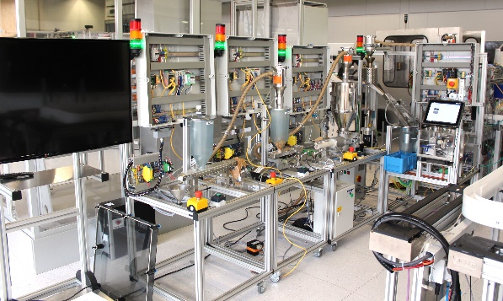In the future, it will be possible to order a custom product, and the production plant will adjust the production process accordingly. Modularity of the plant and the connectivity, where every module can communicate with the others, will allow each product to be individually produced to order of the customer. The Versatile Production System (VPS) is a small-scale industrial plant model developed jointly by the Fraunhofer Application Center Industrial Automation and the Institute Industrial IT of OWL University of Applied Science.

The VPS-Demonstrator © Fraunhofer IOSB

It is designed as a demonstrator, where all the main features of Industry 4.0 come together: modularity, customizability, connectivity and intelligent data analytics.

You will find the VPS in Hall 16, Booth A04.

**Virtual-Reality-Demonstration**

Virtual-Reality-Demo © Fraunhofer IOSB

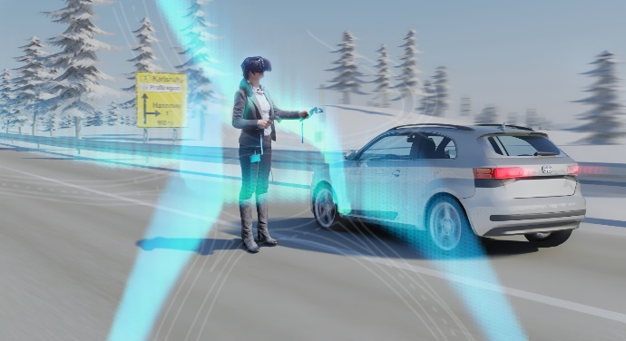Along with its partners KIT and FZI, Fraunhofer IOSB presents the vulnerability of cooperative driving to cyberattacks, based on an example hacking scenario which is been developed and researched in the context of the sub-project »Connected Mobility« in the collaborative research project »Profilregion Mobilitätssysteme Karlsruhe«. In a virtual reality simulation, the visitors are able to experience the attack scenario, which involves a human driver’s smartphone which is infiltrated with malware, and utilized to falsely identify the victim’s car as a cooperative automated vehicle, to provoke a car accident.

You will find this Demo in Hall 27, Booth H71 (Baden-Württemberg International).

Dieses Feld, sowie die Tabelle auf der letzten Seite nicht löschen!